Infosys Springboard Virtual Internship 6.0 Completion Report
Team Details : Yeddu Divya Sri
Arshi sharma
Boggarapu Venkata Srujana

Batch Number: 1 BudgetWise AI based Expense Forecasting Tool
Start date : 13-08-2025
Names:
1 | Aishwarya
2 | Aman Kumar
3 | ANINDA SAU
4 | Haritha Bandi
5 | Jyothi Sri Lakshmi Kuna
6 | Kishore T
7 | Krishna Dongala
8 | Lebi Maria C
9 | Mohd Farhan Khan
10 | Nilancy Agarwal
11 | Pala Yogendra
12 | Patel Tirth Vijaybhai
13 | Polumolu Yamini
14 | Raganamoni Shiva shankar
15 | Rajesh Uda
16 | S.Jeston Singh
17 | Sakalabhaktula Kavyasri
18 | Satyasai Yellayya Devarakonda
19 | Sharukesh Murugavel
20 | Spandana Gudikandula
21 | T NAGA KAVYA
22 | Vaibhavi Shastri
23 | Venkata Shiva Bindu Nemalipuri
24 | Vishalini P
25 | Yamini Mahi Sindhu Mypala

Internship Duration: 8 Weeks

1. Project Title
BudgetWise AI based Expense Forecasting Tool

2. Project Objective
The objective of this project is to build an AI-powered expense forecasting tool that helps users better manage their finances by:
- Tracking and storing monthly expenses in a structured manner
- Analyzing spending behavior to identify patterns and trends
- Predicting future monthly expenses using machine learning for smarter planning
- Providing visual insights through charts and forecast results to support decision-making
- Encouraging financial discipline by alerting users about increasing or high spending
This system ultimately aims to make personal budgeting more efficient, informed, and user-friendly using AI.

3. Project description in detail
BudgetWise – AI Based Expense Forecasting Tool is a smart financial management system designed to help users record, analyze, and predict their monthly expenses. Managing personal finances can be difficult due to uncontrolled spending and lack of proper tracking. This system solves that problem using Machine Learning to forecast future expenses based on a user’s spending history.
The system allows users to input their monthly expense data into the application. Using the stored data, the application processes and analyzes spending patterns. A prediction model (Linear Regression) is applied to forecast the next month’s expenditure. This enables users to understand whether their future expense may increase or decrease. Along with predictions, BudgetWise offers meaningful insights through visual charts and graphs that clearly show spending variations across previous months.
The tool provides an interactive and user-friendly interface developed using Python and Flask, ensuring quick access and smooth navigation. Essential features such as adding new records, viewing charts, error checks, and helping messages are included to support the user experience. The model evaluation metrics like MAE, RMSE, and R² confirm the accuracy and performance of the forecasting system.
By transforming raw financial data into actionable information, BudgetWise assists individuals in making informed financial decisions, controlling overspending, and planning a secure financial future. Overall, this project highlights how Artificial Intelligence can empower personal finance management and support healthy budgeting habits.

4. Timeline Overview
Week | Activities Planned | Activities Completed
Week 1 | Understanding the problem, requirement gathering, and defining project objectives | Requirements analyzed, objectives documented, and workflow planned
Week 2 | Research on expense forecasting methods and selection of ML algorithm | Linear Regression algorithm selected, Flask framework finalized, dataset structure planned
Week 3 | Designing database/data structure for storing expense details | CSV-based dataset format finalized, test data prepared
Week 4 | Data collection and preprocessing | Expense data cleaned, categorized, and prepared for model training
Week 5 | Model development and training using historical expense data | Linear Regression model trained and performance evaluated using MAE, RMSE, R²
Week 6 | Developing the user interface and visualizations | Flask-based UI created with charts for spending trends and forecast results
Week 7 | System integration (Model + Interface + Data Handling) | Prediction module integrated with UI, real-time forecast and alerts enabled
Week 8 | Testing, enhancements, deployment & final documentation | Functional testing completed, bugs fixed, final report prepared, project deployed successfully

5a. Key Milestones
Milestone | Description | Date
Project Kickoff | Defined project objectives, scope, and team roles. | 13-Aug-2025
Prototype / First Draft | Developed the initial version with basic UI and expense forecasting output. | 28-Aug-2025
Mid-Term Review | Presented progress including model training and data visualization; improved based on feedback. | 11-Sep-2025
Final Submission | Completed full BudgetWise system with forecasting, charts, and documentation. | 26-Sep-2025
Presentation | Delivered final presentation demonstrating features and results of the project. | 28-Sep-2025

5b. Project execution details

• Requirement Analysis – Understood user needs, identified lack of expense tracking, and defined objectives for prediction and visualization.
• Technology Selection – Selected Python, Flask as backend framework, Pandas/NumPy for data handling, Matplotlib for charts, and Linear Regression as the forecasting model.
• System Design – Planned application workflow, designed UI structure using HTML/CSS, and finalized CSV-based dataset format for storing expenses.
• Data Collection – Gathered historical monthly expense data and created dummy records for training and testing.
• Data Preprocessing – Cleaned, filtered, and categorized expense values to improve model learning and prediction quality.
• Model Development – Trained Linear Regression model, evaluated with MAE, RMSE & R², and fine-tuned model accuracy.
• Frontend Development – Built a simple and user-friendly interface for input, visual charts, and forecast results with spending suggestions.
• Backend Development – Implemented prediction logic, linked dataset with model, and connected UI through Flask routing.
• Testing & Integration – Performed functional testing, corrected UI and data errors, ensured smooth prediction execution and proper visualization.
• Deployment & Documentation – Deployed the application locally for final demo, prepared PPT, screenshots, and full project documentation.

6. Snapshots / Screenshots
Step 1 : Go to Github and clone the Repository in your system then open in VS Code to do the execution , here is the github repo link : https://github.com/yeddudivyasri/BudgetWise-AI-Based-Expense-Forecasting-Tool
Step 2 : Run python app.py in terminal. And it will generate a link http://127.0.0.1:5000 or type localhost:5000 in browser.
Click on that link it will direct into the login form.
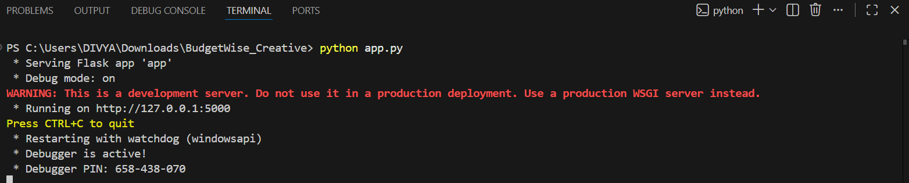

Step 3: The login form consists of default username : divya and password:1234. And there will be register form for the registration of new user. After the registration we can login and open the home page.
Register Form
Register Form and Login Form:
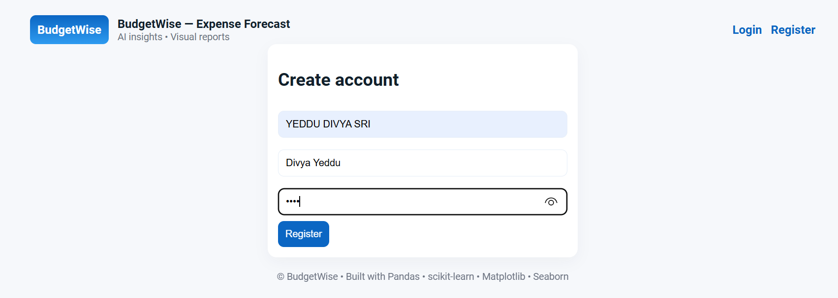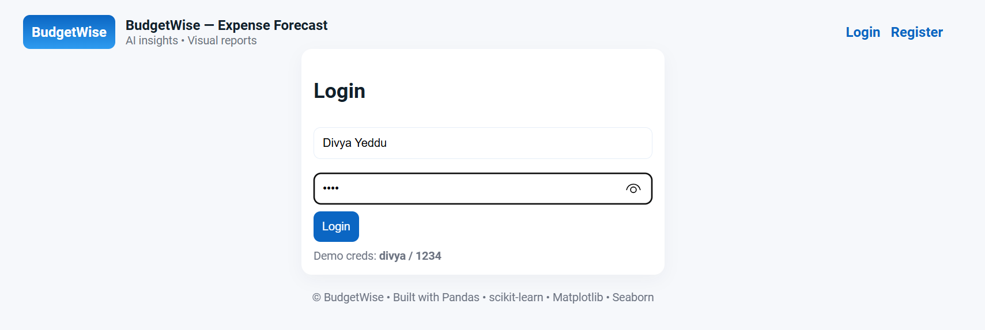

Login Form


Step 4: After clicking on Login/Signup here user need to register and log in for

Step 4 : It will appear as shown in figure after login.
Click the person and select the train months and click predict to see the information and plots.
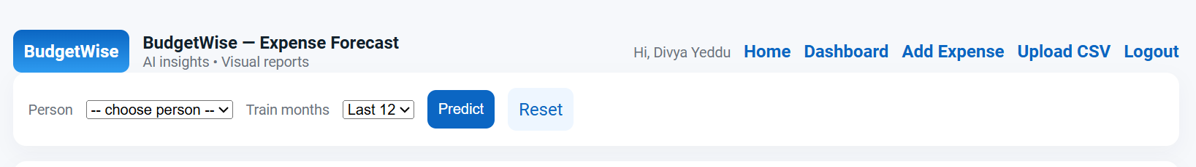

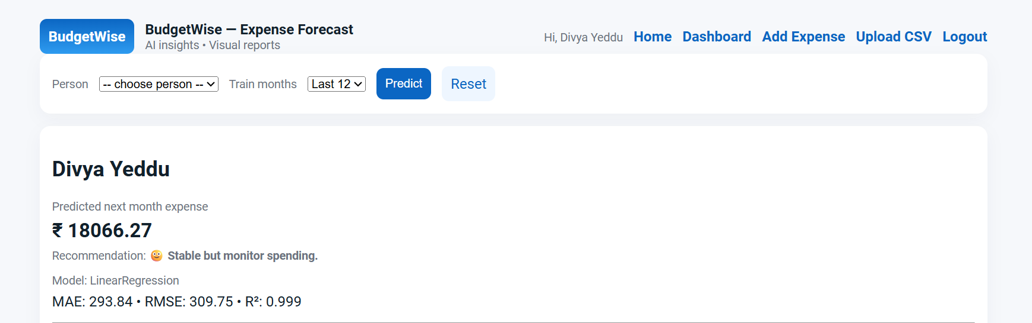

Step 5: VISUALS OF PLOTS:
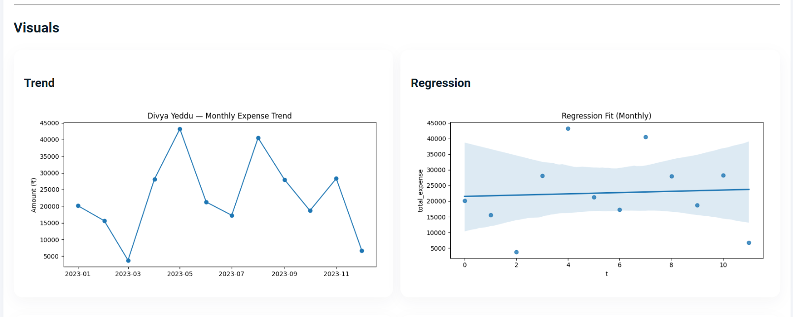
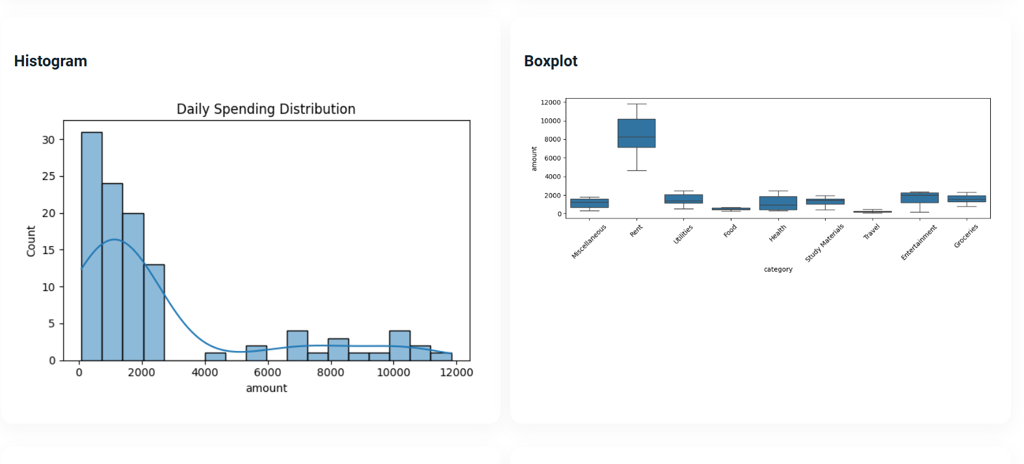
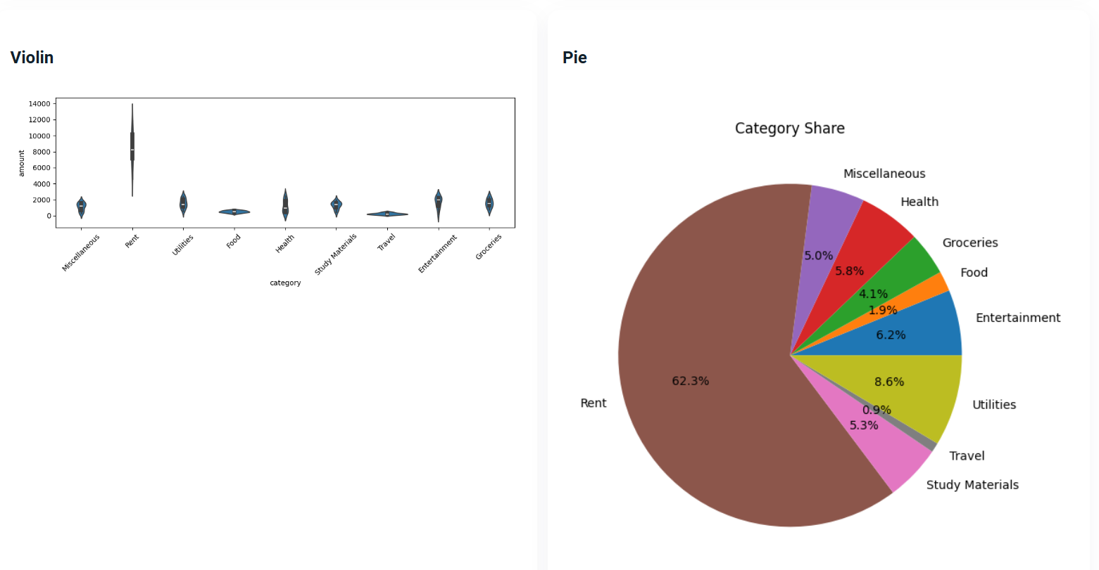
Here we can download the report and open the dashboard
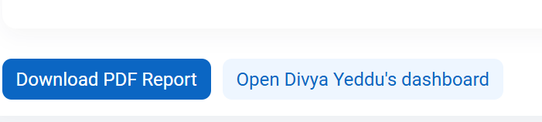

DOWNLOADED REPORT APPERS LIKE THIS:
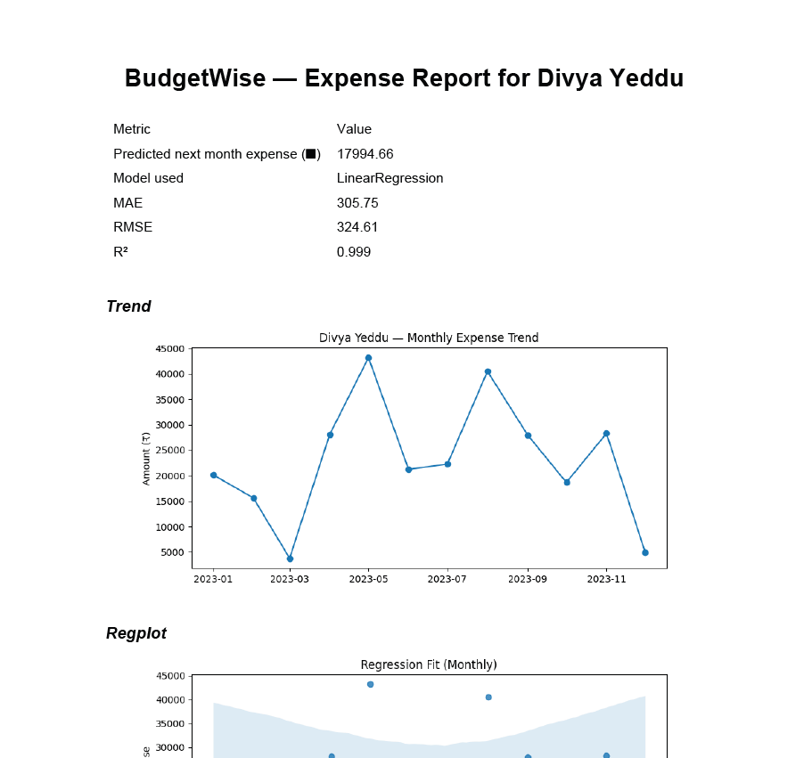

Step 6: Dashboard Overview
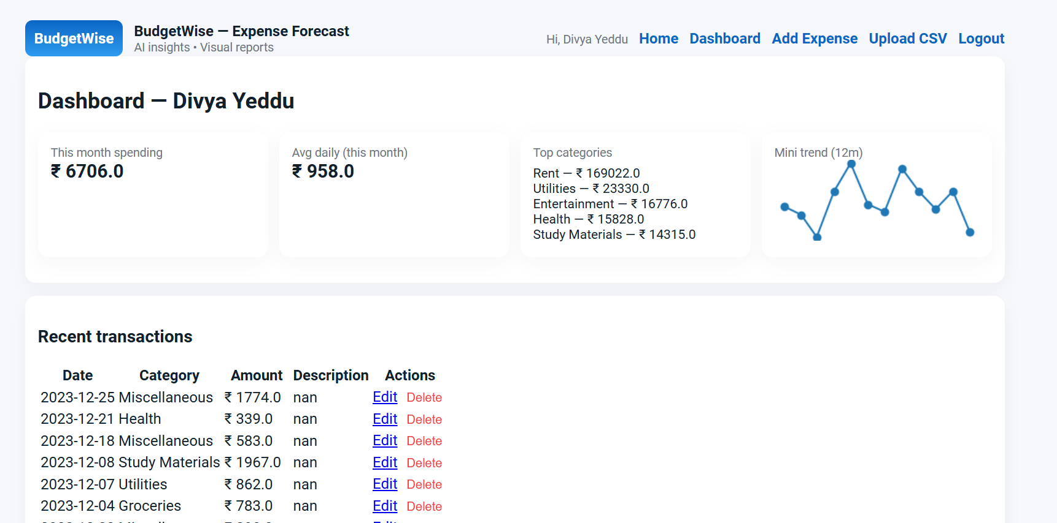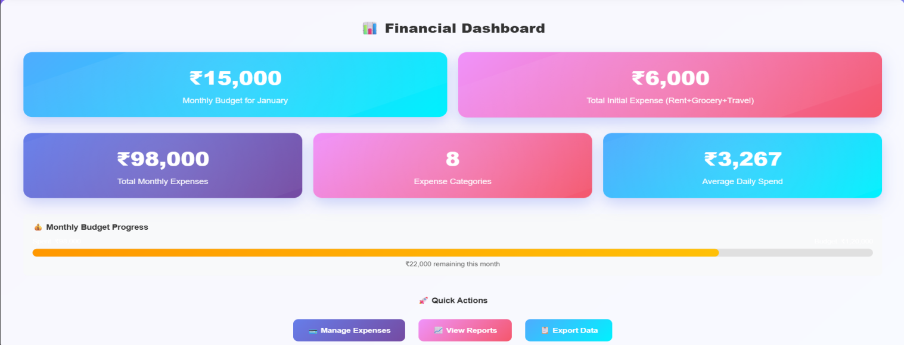

Step 7: Editing the particular Expense from the Transactions
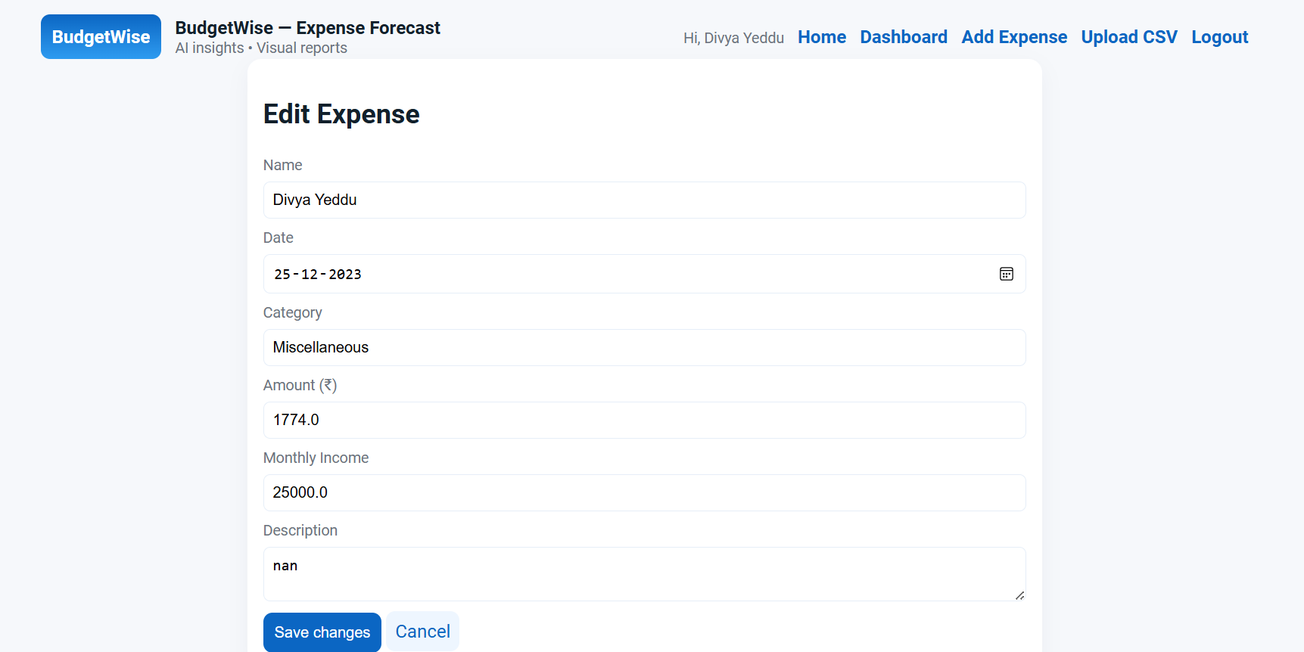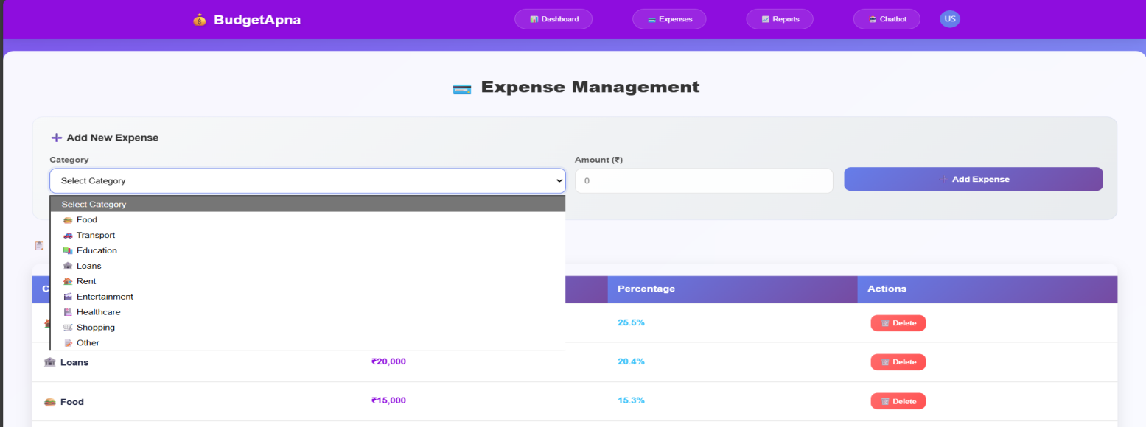

Step 8: Delete the particular transaction
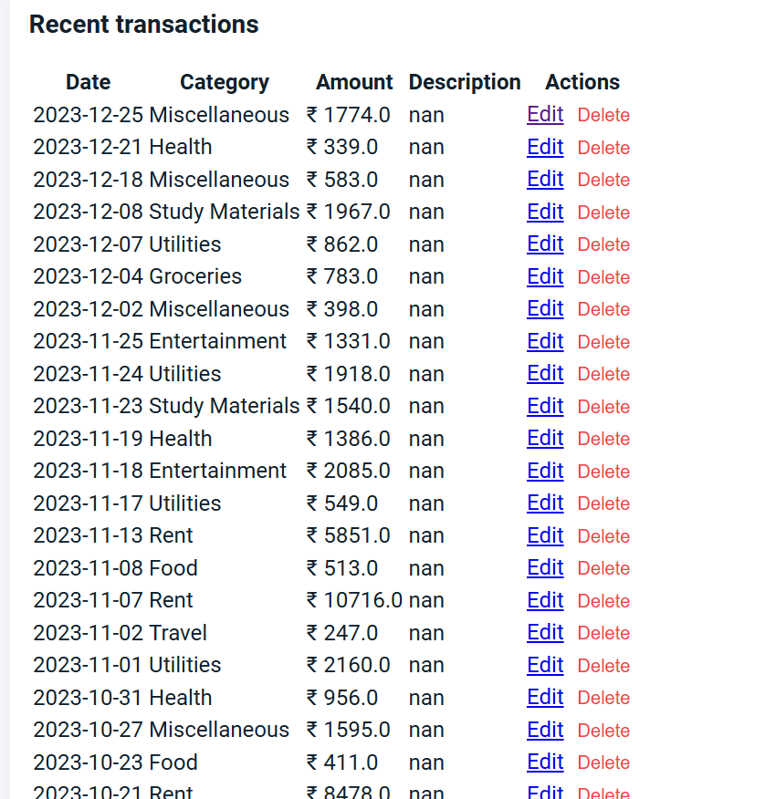
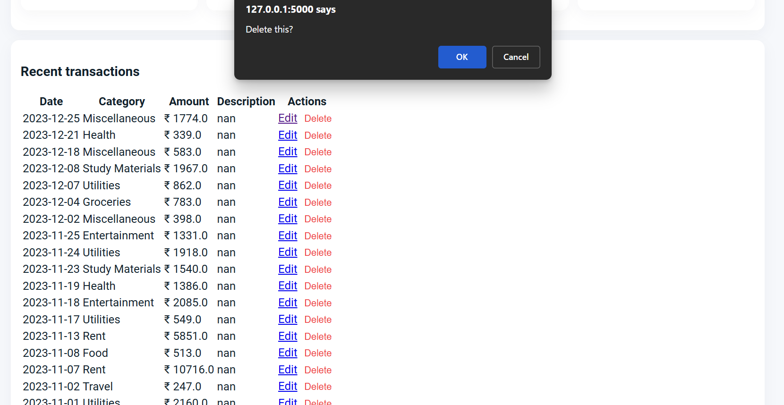
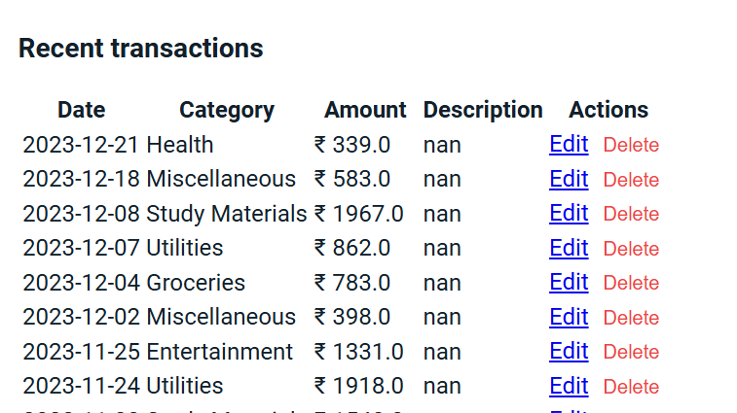
Step 9: Add Expense--- we can add a new transaction
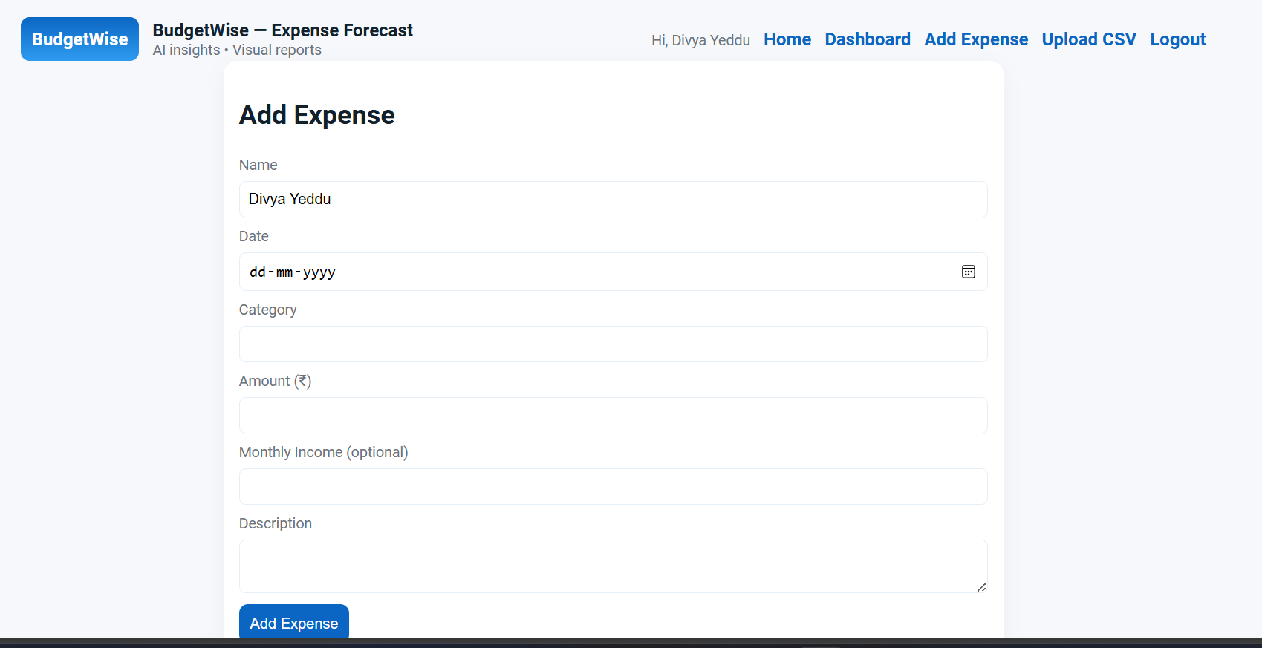
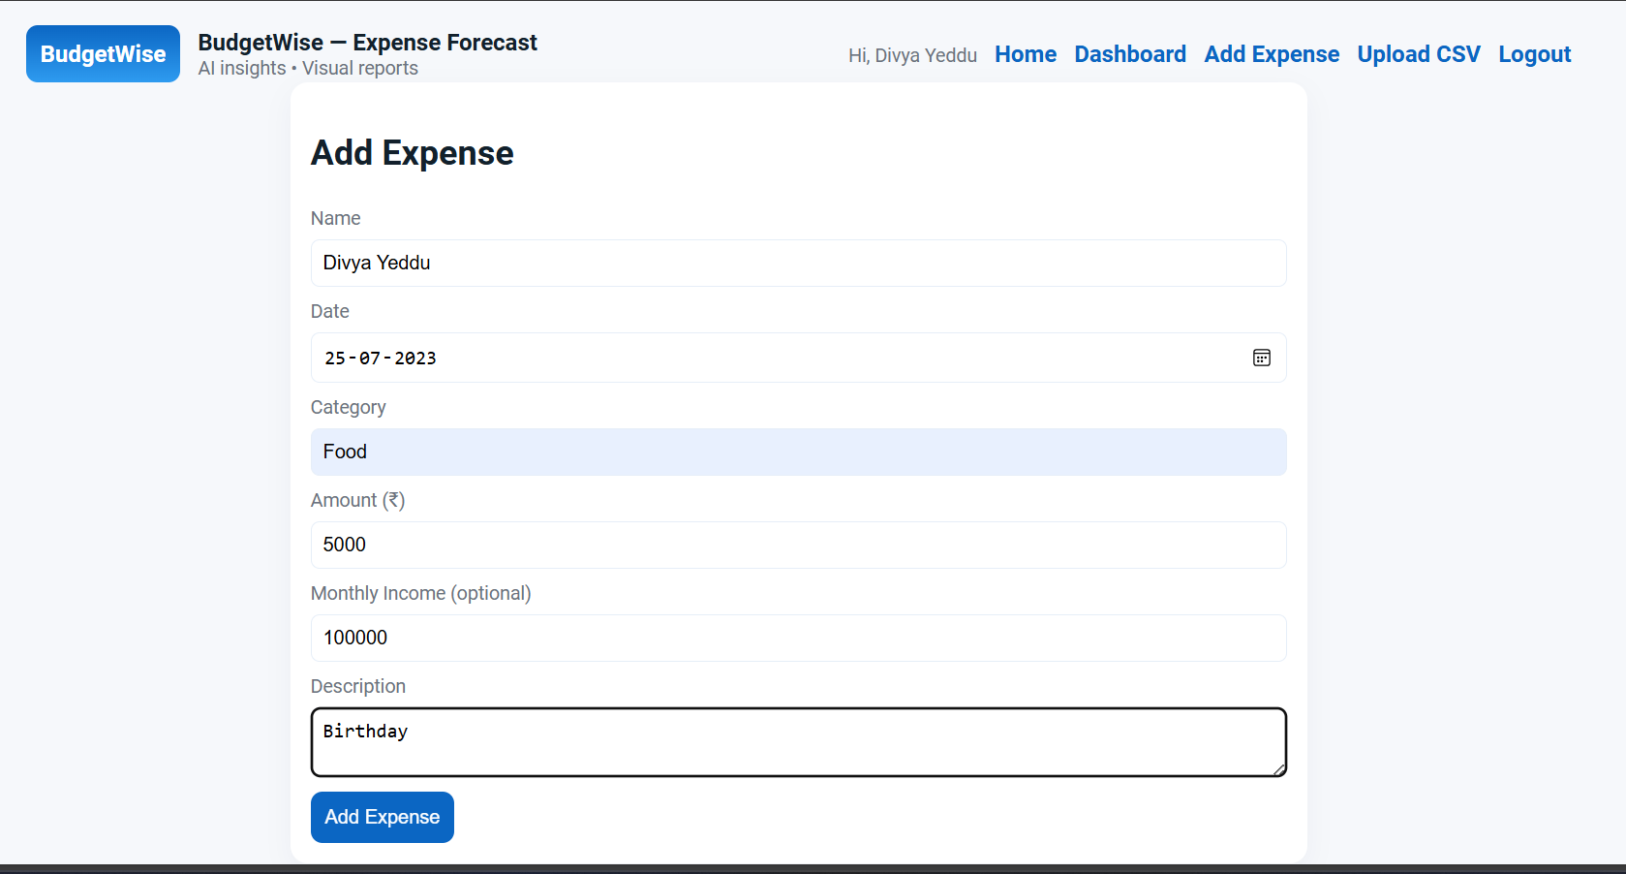

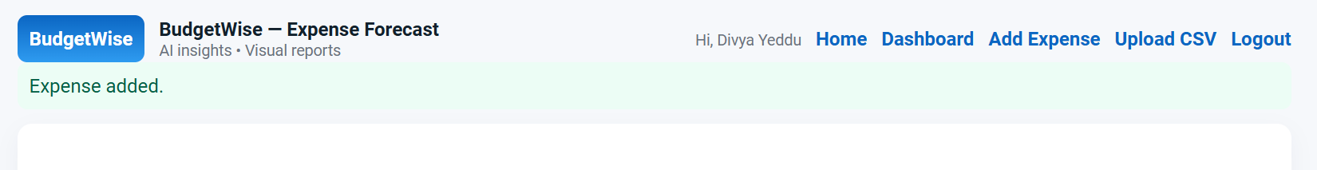Step 10: Here we can upload the CSV.
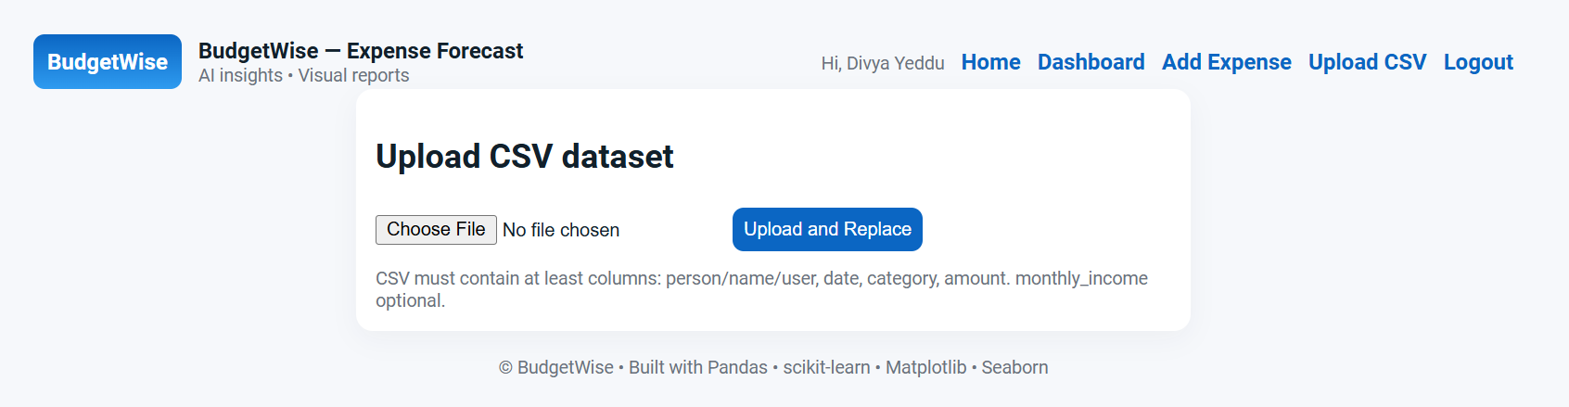

7. Challenges Faced
- Limited Expense Dataset Availability
Real user financial data was difficult to gather, so dummy datasets had to be created for model training.
- Data Inconsistency & Noise
Variations in expense values and missing entries impacted model performance and required additional preprocessing.
- Model Accuracy Optimization
Achieving accurate forecasting using limited historical data took multiple training and evaluation iterations.
- Feature Selection Complexity
Identifying which spending factors contribute most to prediction required analysis and experimentation.
- Frontend & Backend Integration Issues
Ensuring smooth data flow between Flask backend, ML model, and UI required debugging and multiple improvements.
- Visualizing Expense Trends
Implementing meaningful charts and plots demanded proper formatting, performance handling, and layout design.
- Handling Different User Inputs
Validation was needed to prevent incorrect or empty data from affecting forecasting results.
- Time Constraints
Completing UI, model development, testing, and documentation on time required good planning and teamwork.

8. Learnings & Skills Acquired

- Machine Learning Knowledge
Understood how forecasting models work and learned to evaluate model performance using metrics like MAE, RMSE, and R².
- Data Handling & Preprocessing
Improved skills in cleaning, organizing, and preparing real-world financial data for training and predictions.
- Python Programming Skills
Strengthened practical coding using Pandas, NumPy, Matplotlib, and Scikit-Learn libraries.
- Web Application Development (Flask)
Gained experience in building a complete ML-integrated web app with routing, forms, and result rendering.
- Data Visualization Techniques
Learned to create meaningful charts and dashboards for spending trends and forecast outputs.
- Problem-Solving & Debugging
Enhanced analytical thinking while resolving UI issues, model errors, and integration challenges.
- Project Planning & Execution
Developed time management, documentation, and collaboration skills during different phases of the project.
- Presentation & Communication Skills
Gained confidence in presenting project demo, explaining results, and answering review questions.

9. Testimonials from team
Team Member 1:

This project gave me real experience in integrating Machine Learning with a web application. I learned how data-driven insights can help users in real life and improved my skills in Python, Flask, and data visualization. Working in a team helped me collaborate better and deliver a successful solution.

Team Member 2:

Through this project, I learned how machine learning models are trained, evaluated, and used in financial forecasting. The teamwork experience and hands-on practice with project documentation and testing were very valuable.

Team Member 3:

BudgetWise helped me understand the complete software development workflow — from requirement analysis to deployment. I enhanced my problem-solving skills, UI development knowledge, and confidence in presenting our work.

10. Conclusion

BudgetWise is an effective AI-based system that helps users track their monthly expenses and predict future spending accurately. It provides meaningful financial insights through charts and visual reports, making budgeting easier and more informed. The application is simple, user-friendly, and successfully fulfills all the project objectives. The model shows good performance with reliable predictions based on historical data. In the future, BudgetWise can be enhanced with more real-time data sources and advanced features for improved personal finance management.

11. Acknowledgements
Thank the organization, mentor, and any team members who supported your internship journey.
I would like to express my sincere gratitude to Infosys for providing me the opportunity to work on the BudgetWise AI based Expense Forecasting Tool project and gain hands-on experience in AI and ML applications.
I am especially thankful to my mentor, Sangeetha, for their constant guidance, support, and valuable insights throughout the internship. Their mentorship helped me overcome challenges and grow both technically and professionally.
I would also like to thank my team members for their collaboration, encouragement, and efforts in successfully executing this project. Their teamwork made the internship journey smooth and enriching.
Finally, I appreciate everyone who contributed directly or indirectly to my learning and the completion of this project.

